Project Summary
The healthcare system in Pakistan faces significant structural challenges: patients in remote or semi-urban areas are dependent on home-based care, yet the information recorded by nurses during visits rarely reaches physicians in a timely or structured manner. This communication gap results in delayed diagnoses, unnecessary emergency admissions, and fragmented continuity of care particularly for elderly and chronically ill patients who cannot easily commute to hospitals for routine checks.
Healix is an in-development home healthcare coordination platform connecting patients, nurses, doctors, and administrators. The implemented mobile app supports patient profiles, care requests, nurse workflows, visit verification, structured clinical records, and communication. A separate web application supports doctor and administrative work. The backend calculates a rule-based risk level from recorded observations and can flag cases for review. Clinical decisions remain the responsibility of qualified clinicians.
The current clinical intelligence features use deterministic risk rules, keyword-based symptom and knowledge matching, and templated chatbot responses. A trained machine-learning classifier and retrieval-augmented generation (RAG) are planned research and development work; they are not part of the present implementation. Doctor case management, care plans, and prescriptions have partial implementations, while the complete clinical handoff and real-world validation still require work.
The implementation uses an Expo/React Native mobile app, a React/Vite web app, a Node.js/Express backend written in TypeScript, and PostgreSQL accessed through Prisma. Socket.IO supports real-time communication. The architecture is modular, but production integrations such as push delivery, payments, and clinically validated AI remain incomplete.
Healix aims to shorten the interval between home-visit observation and clinician review, improve continuity of care, and support access to coordinated home services. These are intended benefits; clinical effectiveness, safety, scalability, and operational cost have not yet been demonstrated in a live deployment.

Current Implementation Status (October 2026)
The PBD v2.0 code audit records 15 modules and 314 named functionalities: 163 complete, 121 partial, and 30 missing. These are specification-coverage counts, not a measure of clinical readiness or engineering effort. No whole module satisfies every PBD item.
Implemented foundations include authentication and roles, patient records, care requests, nurse matching and contracts, visit verification, clinical observations, messaging, and parts of the doctor and administrator workflows. Remaining priorities include clinical-intelligence validation, reliable external notifications, paramedic/ambulance integration, payments, analytics, and security/compliance hardening.
The assessment is based on source review and selected automated checks. It does not include a live clinical study, production payment or notification tests, or full physical-device validation. Detailed evidence is in docs/maintenance/pbd-completion-audit-2026-10-03.md in the Healix repository.

1. Introduction

1.1 Background and Motivation
The global shift towards digital healthcare often termed 'digital health' or 'e-health' has accelerated following the COVID-19 pandemic, which demonstrated both the fragility of traditional healthcare infrastructure and the viability of remote care delivery. Telemedicine platforms, AI-assisted diagnostics, and mobile health (mHealth) applications have emerged as foundational pillars in this transformation. International healthcare systems, including the UK's NHS Digital programme and India's Ayushman Bharat Digital Mission, have demonstrated that technology-mediated healthcare can significantly improve patient outcomes, reduce costs, and extend care to underserved populations.
In Pakistan, home-based care is a common reality particularly for elderly patients, those with chronic illnesses, and individuals in areas with limited hospital infrastructure. Community nurses and caregivers perform regular home visits to record patient vitals and administer basic treatments. However, the data recorded during these visits is almost entirely manual, paper-based, and unstructured, making it inaccessible to physicians until a physical handover occurs. This latency in data transmission can be clinically dangerous: a deteriorating patient may not receive timely medical intervention simply because the nurse's observations have not yet reached a doctor.
Healix is motivated by the need to make home-visit observations available to authorized clinicians promptly and in a structured form. The project combines care coordination with patient records, visit verification, communication, and decision-support prototypes while keeping medical judgment with clinicians.

1.2 Industry Relevance and Current Trends
Relevant digital-health trends include structured remote monitoring, mobile care coordination, teleconsultation, and cautious use of clinical decision support. Market-size forecasts in the earlier proposal have been removed because they were not tied to a verifiable source or to the project's implementation status.
Specifically in the home healthcare domain, platforms such as CERA Care (UK), Birdie, and Honor (USA) have demonstrated the commercial and clinical viability of digitising home visit workflows. These platforms allow caregivers to log structured visit data through mobile apps, enabling supervisors and clinicians to review patient status in real time. Healix draws architectural inspiration from these systems while tailoring its design to the Pakistani healthcare context including local connectivity constraints, regulatory considerations, and the role of government-affiliated physicians.

1.3 System Concept Overview
Healix has patient and nurse workflows in the Expo mobile app and doctor and administrator workflows across the backend and web app. A patient requests care; a nurse can accept or manage the visit, verify attendance using QR/GPS-related workflows, and record observations. The backend produces a rule-based risk assessment, and authorized doctors can review clinical information and record decisions in implemented flows. Some screens and handoffs remain partial; the chatbot provides general, templated guidance only.
The broader product scope also includes nurse discovery and bidding, bilateral contracts, communication, emergency response, billing, analytics, and security controls. These areas have differing levels of completion and are not presented as production-ready clinical services.

2. Literature Review
This section reviews ten relevant research works and existing systems in the domains of AI-assisted clinical decision support, remote patient monitoring, home healthcare applications, and machine learning–based risk stratification. The review identifies key contributions and limitations that inform the design of Healix.
- Fernandez-Luque & Bau (2015) – Health and Social Media: Perfect Storm of Information. This foundational study examined how digital information sharing through social and mobile platforms could support health management. It demonstrated that patients who engaged with digital health tools showed improved adherence to care plans. Limitation: lacked a clinical-grade data pipeline and AI integration.
- Mohan et al. (2011) – Application of Machine Learning in Disease Prediction. This paper evaluated several supervised learning algorithms (Naïve Bayes, SVM, Decision Trees) for disease prediction using patient health records. Accuracy of up to 82% was achieved. Limitation: datasets were clinical, not from home visit settings, and real-time deployment was not addressed.
- Obermeyer & Emanuel (2016) – Predicting the Future – Big Data, Machine Learning, and Clinical Medicine. This seminal review in the NEJM argued that ML models trained on large clinical datasets could outperform physician-based heuristics for risk stratification. Limitation: the models relied on large hospital EHR datasets not accessible in developing countries.
- Topol (2019) – High-Performance Medicine: The Convergence of Human and Artificial Intelligence. This comprehensive review argued that AI could autonomously detect disease from imaging, EEG, and physiological signals. Relevant to Healix's use of vital signs for automated risk scoring. Limitation: focused on high-resource settings with imaging infrastructure.
- Choi et al. (2016) – RETAIN: An Interpretable Predictive Model for Healthcare Using Reverse Time Attention. RETAIN used recurrent neural networks with attention mechanisms on EHR data to predict heart failure onset. Achieved high AUC while remaining interpretable. Limitation: required longitudinal EHR data, which is unavailable in ad hoc home visit contexts.
- Kario et al. (2020) – Digital Hypertension 2020: From Evidence to Practice. This study validated a mobile-based blood pressure monitoring and telemedicine system in Japan, demonstrating that home BP readings transmitted digitally could guide antihypertensive therapy. Highly relevant to Healix's vital sign collection module. Limitation: single-disease focus.
- RPM (Remote Patient Monitoring) Systems Review – Lüscher et al. (2022) – A systematic review of 42 RPM deployments concluded that continuous digital monitoring significantly reduced unplanned hospital readmissions in chronic disease patients. The review highlighted that systems combining structured data collection, automated alerts, and clinician review achieved the highest outcomes precisely the model Healix implements.
- Birdie (UK) – A care management platform for domiciliary care agencies. Birdie provides digital care plans, medication tracking, and family visibility portals. It focuses on administrative coordination rather than clinical risk analysis a gap Healix addresses directly through ML risk classification.
- Sehat Kahani (Pakistan) – A Pakistani telemedicine platform connecting patients with female doctors via mobile app. It addresses the urban-rural doctor access gap. However, it lacks home visit workflows, AI clinical support, and structured vital sign collection.
- Practo (India) – A telemedicine and health records platform enabling online doctor consultations and digital prescriptions. Relevant to Healix's doctor consultation workflow. Practo, however, does not include nurse visit data collection or AI-based risk escalation.
- Cera Care (UK) – A home healthcare platform focused on elderly care and domiciliary services. The system enables caregivers to record patient data during home visits and applies predictive analytics to identify potential health deterioration. It demonstrates the effectiveness of data-driven care in home environments and highlights the role of AI in improving patient monitoring outside hospital settings.

- Honor (USA) – A caregiver coordination platform designed to manage home care services through scheduling, caregiver tracking, and operational logistics. It improves efficiency and transparency in service delivery for care agencies and provides a structured approach to managing large-scale home healthcare operations.

- CarePredict – An AI-enabled monitoring system that utilizes wearable devices to track elderly patient behavior, including movement, sleep patterns, and daily activities. The system detects anomalies that may indicate health deterioration, supporting preventive care and continuous remote monitoring of patients.

- Babylon Health – A digital healthcare platform combining AI-driven symptom checking with telemedicine consultations. It allows users to interact with an AI chatbot and access virtual doctor consultations, improving accessibility and convenience in healthcare delivery through intelligent digital interfaces.

- Teladoc Health – A global telemedicine provider offering remote consultations, mental health services, and virtual care delivery. It has demonstrated scalability in delivering healthcare services across diverse populations and plays a significant role in expanding access to medical expertise through digital platforms.

Feature / System | Birdie | Sehat Kahani | Practo | Cera Care | Babylon Health | Healix target / current
Home Nurse Workflow | Varies | Varies | Varies | Varies | Varies | Implemented
Structured Vitals Collection | Varies | Varies | Varies | Varies | Varies | Implemented
AI Risk Classification | Varies | Varies | Varies | Varies | Varies | Rule-based
Real-Time Doctor Escalation | Varies | Varies | Varies | Varies | Varies | Partial
Doctor Dashboard (Clinical View) | Varies | Varies | Varies | Varies | Varies | Partial
AI Clinical Decision Support (RAG) | Varies | Varies | Varies | Varies | Varies | Planned
Uses Real Clinical Data (Vitals) | Varies | Varies | Varies | Varies | Varies | Implemented
End-to-End Care Workflow | Varies | Varies | Varies | Varies | Varies | Partial
Works in Low-Resource Settings | Varies | Varies | Varies | Varies | Varies | To validate
AI + Human Collaboration | Varies | Varies | Varies | Varies | Varies | Partial

3. Problem Statement
Despite the availability of home-based nursing services in Pakistan, the healthcare system suffers from a fundamental disconnect between data collection and clinical decision-making. The following problems are directly addressed by Healix:

3.1 Delayed Clinical Decision-Making
Paper or fragmented home-visit records can delay clinical review. Healix addresses this by recording structured observations and making them accessible to authorized clinicians. Its current alerting and escalation flows require further end-to-end and device validation before reliance in time-critical care.

3.2 Unstructured and Incomplete Health Records
Paper-based nursing notes are unstructured, inconsistent in format, and prone to transcription errors. Critical data such as blood pressure trends, oxygen saturation patterns, or symptom escalations over multiple visits is rarely aggregated or analysed. Without longitudinal structured data, it is impossible to apply predictive analytics or detect early deterioration patterns even when the raw information has been collected.

3.3 Limited Access to Medical Expertise
In many areas of Pakistan, the doctor-to-population ratio remains critically low. Patients who require clinical review often face long wait times at public hospitals, high costs at private clinics, or simply lack the physical ability to travel. Remote physician involvement mediated through a digital platform can substantially expand clinical reach without requiring infrastructure investment.

3.4 Absence of AI-Assisted Triage in Community Care
Home-visit triage can help prioritize review, but a risk score is not a diagnosis. The current Healix prototype uses explicit rules rather than a trained ML model. Evaluating any future predictive model for safety, bias, calibration, and clinician usefulness is part of the remaining research.

3.5 Poor Healthcare Continuity for Chronic Patients
Patients with chronic conditions such as diabetes, hypertension, COPD, or heart failure require consistent monitoring and care plan adjustments. The current home care model provides episodic, disconnected visits with no longitudinal health record accessible to the treating physician. This results in repeated assessments from scratch, medication errors, and suboptimal disease management.

4. Proposed Solution
Healix is a modular home healthcare platform with patient, nurse, doctor, and administrator workflows. It combines care requests, nurse matching and visits, structured clinical records, clinician review, and communication. Clinical intelligence currently consists of rule-based and keyword-based support. Ambulance/paramedic, billing, analytics, and compliance capabilities are still incomplete.

4.1 System Architecture Overview
The client-server architecture consists of an Expo/React Native mobile application, a React/Vite web application, and a TypeScript Node.js/Express REST API. PostgreSQL is the primary database, with Prisma providing data access and migrations; Socket.IO supports real-time messaging. Authentication and role-based authorization are implemented in the backend. There is no deployed Python ML microservice, vector database, or RAG service in the current codebase.
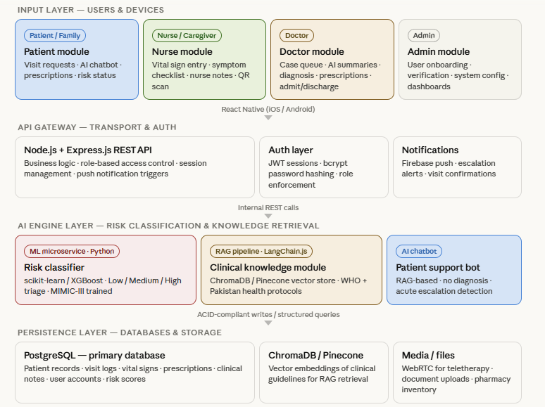

4.2 Patient Module
The patient workflow currently includes account access, profile and medical information, care requests, nurse discovery, communication, and selected clinical views. The following items describe the target scope; items still needing integration are identified explicitly:
- Register and log in with secure authentication (JWT-based sessions).
- Create and update their personal health profile, including age, weight, known diagnoses, allergies, and current medications.
- Submit a nurse visit request, specifying the nature of care required and preferred timing.
- View a rule-based health risk status where the related clinical record is available; this is not an ML prediction.
- View prescriptions and clinical notes added by the assigned doctor.
- Use a general-guidance chatbot prototype with templated responses; patient-specific RAG answers remain planned.
- Receive in-app status and message updates; reliable device push notification delivery remains to be integrated and tested.

4.3 Nurse / Caregiver Module
The nurse workflow supports availability, care requests, visits, verification, and clinical data entry. Structured observations can include the following values when relevant to a visit:
Basic Visit Information: Visit date and time, patient ID (scanned via QR or manually entered), GPS-verified visit location, and nurse ID.

Vital signs and measurements (inputs to the current rule-based assessment):
- Blood Pressure (Systolic / Diastolic, mmHg)
- Heart Rate (bpm)
- Oxygen Saturation / SpO₂ (%)
- Body Temperature (°C)
- Blood Glucose Level (mg/dL)
- Respiratory Rate (breaths/min)
- Body Weight (kg) and calculated BMI

Symptom Checklist: A standardised binary/scale symptom form covering: Chest pain, Headache, Dizziness, Fatigue, Peripheral swelling, Cough (dry/productive), and overall severity score.

Nurse Comments: A free-text observation field for qualitative clinical notes.

Submitted observations are stored by the backend and may be evaluated by the current rule-based risk service. The nurse and doctor views need further end-to-end verification before this can be described as a clinically reliable escalation pathway.

4.4 Doctor Module
The backend supports doctor registration and authorization. Administrative verification and invite/assignment workflows are incomplete; the following onboarding models remain targets:
Admin-managed onboarding: verify clinician identity and qualifications, then grant appropriate access and assignments (planned completion).

Invite-based onboarding: provide a secure invitation and review process for qualified doctors (planned completion).

Through the Doctor Dashboard, a physician can:
- View clinical cases and available risk information; priority ordering and real-time alert behavior require validation.
- Access complete patient history, including all previous visit records, vitals trends, and nurse notes.
- Review structured case data and existing rule/keyword-derived support. Generated RAG recommendations are not yet implemented.
- Enter a clinical diagnosis, treatment recommendations, and medication prescriptions.
- Instruct the nurse to administer a specific treatment or extend monitoring.
- Record a recommendation for higher-level care when appropriate; integrated hospital admission referral remains future work.
- Discharge a patient from active monitoring once clinically stable.

4.5 Clinical Intelligence: Current Rules and Planned ML/RAG
The present implementation is a decision-support prototype. Its risk service applies deterministic thresholds and scoring; symptom matching, knowledge search, and chatbot replies use keyword or template logic. The following ML and RAG functions are proposed extensions requiring data governance and clinical evaluation.
4.5.1 Planned ML Risk Classifier: The proposed model would use appropriately governed, labelled clinical observations to estimate Low, Medium, or High risk. The present rule-based assessment must not be represented as a trained classifier or a validated medical device.
- Low risk: no rule-triggered concern in the available inputs; continue clinician-directed monitoring.
- Medium risk: observations warrant review or closer monitoring according to configured rules.
- High risk: rule-triggered concern that should be promptly reviewed by a qualified clinician; emergency symptoms require existing emergency-care procedures.

Future ML work includes selecting lawful and representative datasets, defining clinician-reviewed labels, establishing baselines, and measuring sensitivity, specificity, calibration, fairness, and failure cases. Public or synthetic data alone cannot establish clinical validity for the intended Pakistani population.

4.5.2 Planned RAG-Based Knowledge Support: A future system may retrieve approved, versioned clinical guidance and present cited passages to doctors. The current codebase has keyword-based knowledge lookup, not vector retrieval or generated clinical recommendations. Any generated content would require source traceability and human review.
- Curate and license clinical guidelines, record versions, and retrieve relevant passages with citations (planned).
- Prepare a structured case summary from verified patient data and recent observations (planned integration).
- Show suggested considerations with provenance and uncertainty for clinician review, never autonomous diagnosis (planned).

A vector index and language-model service are potential future choices; no LangChain, ChromaDB, Pinecone, or production RAG integration is implemented at present.

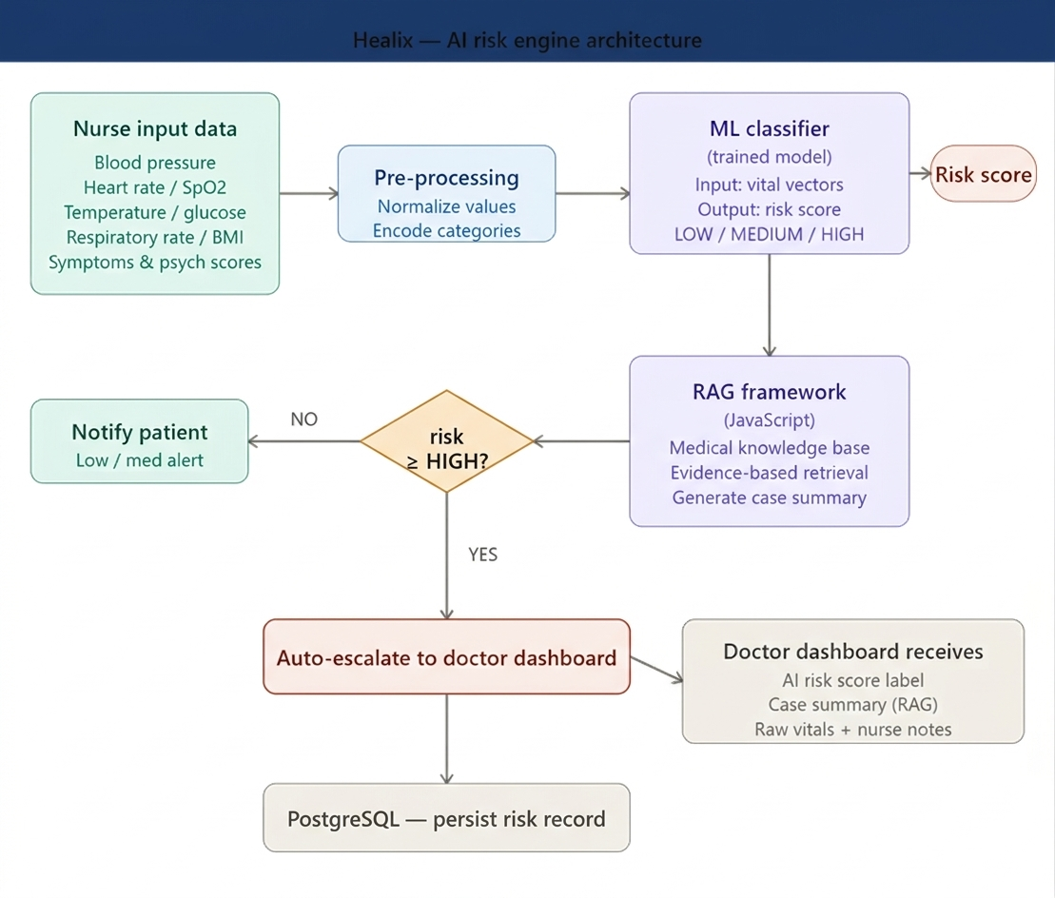

4.6 AI Chatbot Module
The current patient chatbot offers limited general information through templates and keyword matching. The proposed expansion would provide sourced, context-aware guidance with clear safety boundaries; it would require privacy review and clinical evaluation.
- Answer general questions using approved content; personalized RAG answers remain planned.
- Display existing patient information where authorized; profile-aware medical advice remains out of the current implementation.
- Direct potentially urgent symptoms to appropriate emergency services and human clinical review; reliable automated urgent alert delivery remains planned.
- The chatbot explicitly does not replace clinical diagnosis.

4.7 Administrator Module
The Administrator has system-wide oversight and control. Administrator functions include:
- Manage staff accounts and permissions; full credential verification workflows remain incomplete.
- View available operational data; comprehensive clinical and business analytics remain partial.
- Managing system configuration parameters and access policies.

4.8 Complete System Workflow
- Patient or family member submits a nurse visit request through the app.
- A nurse is matched, accepts, or is assigned through the available care-management workflow; automated scheduling remains partial.
- Nurse visits the patient and enters structured vital signs, symptom data, and clinical observations.
- The backend calculates a rule-based risk level from submitted observations where the clinical workflow invokes it.
- If risk is Low: the nurse continues scheduled monitoring; no immediate escalation.
- Medium or high risk can be flagged for doctor review; alert delivery and prioritization require full integration testing.
- The doctor reviews available records and rule-based support; RAG suggestions remain future work.
- The doctor enters a clinical decision: continue monitoring, adjust treatment, prescribe medication, or recommend admission.
- Follow-up instructions can be recorded and communicated through implemented flows; notification coverage remains partial.
- The patient is notified of the outcome and can view the prescription or care plan in their app.
- The patient can access general-guidance chatbot content; personalized clinical advice is not provided by the current prototype.
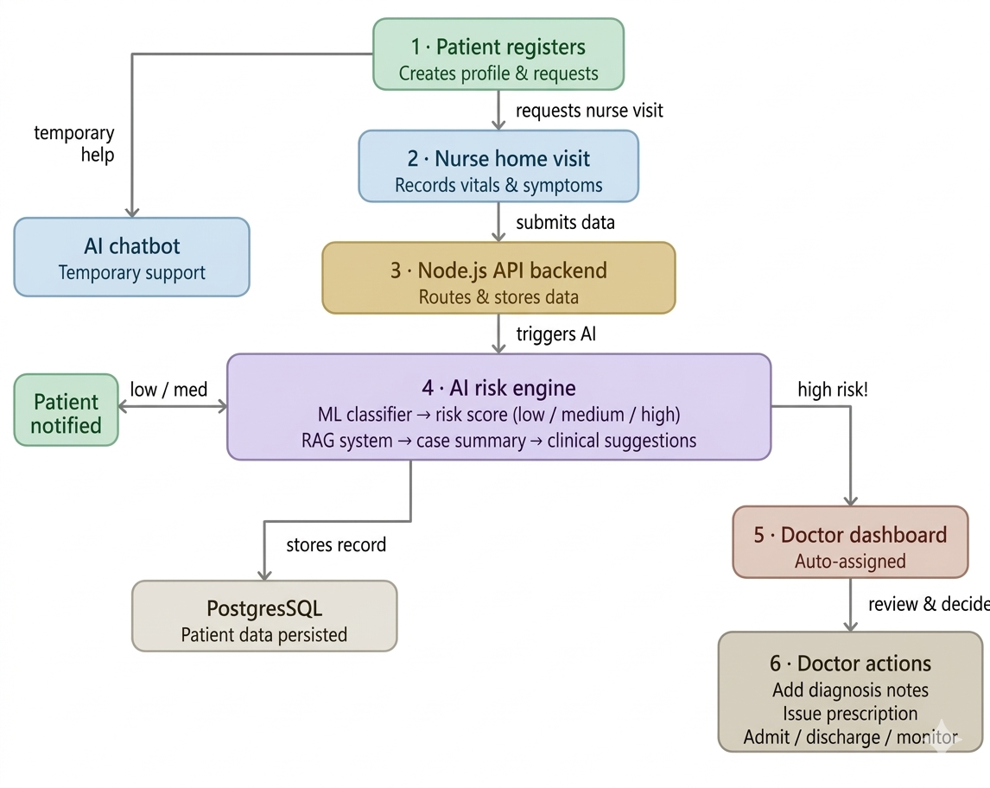

5. Vision Statement
Healix aims to improve access to coordinated home care in Pakistan. The current implementation is a research and development prototype, so the following are long-term objectives rather than measured outcomes:
- Investigate whether timely clinician review of home observations can reduce avoidable deterioration or hospital visits.
- Empower nurses as technologically equipped frontline healthcare workers rather than passive data collectors.
- Help qualified physicians prioritize cases with transparent decision-support signals, subject to clinical validation.
- Establish a longitudinal digital health record for every patient enrolled in the system, creating the data foundation for population-level health analytics and policy planning.
- Evaluate broader deployment only after security, reliability, clinical, and operational requirements have been met.

6. Scope

6.1 Included (In-Scope)
- User ecosystem: patient, nurse, doctor, and administrator workflows, with paramedic and ambulance capabilities under development.
- Structured visits: capture vital signs, symptoms, notes, and verification information during nurse-led care.
- Risk assessment: maintain explainable rule-based triage now and research clinically validated ML as a future extension.
- Clinical decision support: provide clinician access to records now; sourced RAG recommendations remain planned.
- Escalation: flag concerning observations for doctor review and complete reliable alerts and end-to-end validation.
- Patient guidance: provide limited general chatbot responses now and evaluate safe, sourced enhancements later.

6.2 Excluded (Out-of-Scope)
- Medical hardware manufacturing: the project does not build or certify measurement devices; observations are manually entered.
- Public emergency dispatch integration: internal ambulance/paramedic models are partial, but integration with Rescue 1122 or a live emergency fleet is outside the present validated scope.
- Surgical management: operating-room scheduling and procedures are outside the project scope.
- Medicine delivery logistics: prescription records exist, but physical pharmacy fulfillment and delivery are outside the current implementation.

7. Methodology
Healix follows iterative prototyping and incremental implementation. Requirements are compared with working backend, mobile, and web workflows; gaps are documented and prioritized. Interface reviews with clinicians and patients remain necessary before claiming usability or clinical suitability. Safety-related features require stronger validation than ordinary application flows.
The next iterations focus on reliable care and clinical handoffs, complete doctor and paramedic workflows, real notifications, payment reconciliation, privacy controls, and controlled clinical evaluation. Any proposed ML or RAG component will first need governed data, measurable objectives, and clinician review before deployment.

8. Technical Stack and Current Implementation

Mobile Frontend – Expo and React Native
The mobile application uses Expo SDK 57, Expo Router, React Native, and TypeScript for patient and nurse experiences and selected shared flows. Doctor and paramedic mobile coverage is incomplete.

Backend – Node.js, Express, and TypeScript
The API implements domain services, role-based access control, and real-time communication using Socket.IO. Integration and security hardening remain ongoing work.

Database – PostgreSQL and Prisma
PostgreSQL stores relational clinical and operational records. Prisma manages the schema and database access. Production migrations, backups, and retention controls need operational validation.

Authentication – JWT and bcrypt
The backend uses JWT-based sessions, password hashing, and role guards. Real OTP delivery and complete account verification remain unfinished; these controls do not establish compliance certification.

Clinical Risk Assessment – TypeScript Rules
The implemented risk engine uses deterministic logic. A Python/scikit-learn or XGBoost service is a research option, not an existing component.

Knowledge Support – Keyword Search (RAG Planned)
The present knowledge lookup is keyword-based. A curated, cited RAG pipeline and clinician validation are planned; LangChain.js and ChromaDB are not implemented dependencies.

Patient Chatbot – Template-Based Prototype
The chatbot currently returns general templated guidance. Personalized, context-aware answers would need approved sources, privacy safeguards, and clinical review.

10. Applications of this Project
10.1 Rural and Semi-Urban Healthcare Delivery
In many rural and semi-urban regions of Pakistan, such as areas surrounding Attock, access to hospitals and qualified physicians is limited. Patients often rely on periodic home visits by nurses, and critical health data is delayed due to manual record-keeping. Healix enables nurses to digitally record patient vitals during home visits and instantly transmit this data to doctors located in urban centers like Islamabad. The integrated AI system evaluates the patient’s condition in real time and flags high-risk cases, allowing doctors to intervene remotely. This significantly reduces delays in diagnosis and improves patient outcomes.
10.2 Chronic Disease Management
Chronic illnesses such as diabetes, hypertension, and cardiovascular diseases require continuous monitoring and timely adjustments in treatment. Healix provides a structured system where nurses regularly input patient vitals, and the AI engine detects trends and abnormalities over time. Doctors can review these insights remotely and modify treatment plans without requiring the patient to visit a hospital. This ensures better disease control, reduces complications, and enhances long-term patient care.
10.3 Post-Hospital Discharge Monitoring
Patients discharged after surgeries or critical care often require close monitoring to prevent complications. Healix facilitates this by allowing nurses to conduct follow-up visits and record recovery data such as temperature, oxygen levels, and heart rate. The AI system analyzes this data to detect early signs of infection or deterioration. If any risk is identified, the system alerts the doctor immediately, reducing the likelihood of hospital readmission and improving recovery outcomes.
10.4 Government and Public Health Integration
Healix can be integrated into public healthcare systems, including Basic Health Units (BHUs) and community health worker programs. By digitizing patient data collection and centralizing it on a unified platform, healthcare authorities can monitor population health trends in real time. This enables better resource allocation, faster response to health crises, and improved policy-making based on accurate data.

10.5 Telemedicine Enhancement
Existing telemedicine platforms, such as Sehat Kahani, primarily rely on video consultations without access to structured clinical data. Healix enhances these platforms by providing real-time patient vitals and AI-driven risk assessments before consultations. This allows doctors to make more informed decisions, increasing the accuracy and effectiveness of remote healthcare services.
10.6 Private Home Healthcare Services
Private home healthcare providers can use Healix to replace manual record-keeping with a digital system. Inspired by platforms like Birdie, Healix allows organizations to monitor nurse activities, track patient progress, and manage care efficiently. This improves operational transparency, enhances service quality, and enables scalability for healthcare businesses.

11. Work Breakdown and Forward Plan

Phase 1: Requirements and architecture – completed foundation
Core roles, relational data model, and major workflows have been defined and implemented in the repository. Requirements are tracked against the Product Breakdown Document (PBD) v2.0.
Key Activities:
- Document clinical and operational requirements
- Define patient, nurse, doctor, and administrator workflows
- Maintain the PBD-to-code coverage audit
- Review data model and risk-rule assumptions with clinicians
Milestone: documented baseline and identified gaps; clinical sign-off remains pending.

Phase 2: Product flows and interfaces – substantial prototype
Patient and nurse mobile flows and doctor/admin web views exist. Mobile doctor/paramedic coverage, accessibility, and real-user evaluation remain incomplete.
Key Activities:
- Refine nurse observation and visit verification screens
- Complete escalation and doctor decision interfaces
- Align web and mobile payloads with backend contracts
- Conduct structured usability reviews with intended users
Milestone: usable role workflows verified on target devices.

Phase 3: Core backend and patient care – implemented with gaps
The Node.js/TypeScript API, PostgreSQL/Prisma schema, and patient care records are implemented. Remaining work includes live database migration testing, notification delivery, and integrated workflow validation.
Key Activities:
- Develop Node.js REST API
- Maintain PostgreSQL/Prisma schema and migrations
- Validate Expo mobile patient and nurse flows on real devices
- Implement patient registration and medical history features
Dependency: stable data contracts and authorized clinical access.

Phase 4: Clinical workflow and decision support – partial
Nurse clinical data capture and deterministic risk scoring exist; trained ML and RAG do not. Doctor review, prescription output, escalation, and care-plan handoffs require completion and validation.
Key Activities:
- Develop nurse vitals input module
- Evaluate risk rules with clinician-reviewed cases; research ML only after dataset governance
- Design sourced knowledge retrieval and human-reviewed clinical support
Milestone: verified nurse-to-doctor handoff with safe escalation behavior.

Phase 5: Administration, notifications, and operations – partial
Administrative account management and in-app communication exist. Real push/SMS/email delivery, complete verification, payments, ambulance operations, and analytics remain partial or missing.
Key Activities:
- Complete clinician credential verification and administrator controls
- Integrate and test notification providers across supported devices
- Implement payment reconciliation and operational reporting where in scope
Dependency: provider selection, test environments, and data-protection review.
Milestone: auditable administrative and notification flows.

Phase 6: Verification and clinical evaluation – pending
Existing automated tests cover selected backend and mobile paths, but no live clinical validation or comprehensive device/provider testing has been completed.
Key Activities:
- Test patient → nurse → doctor flows against a live test database
- Run device, accessibility, security, and failure-mode tests
- Evaluate risk performance with clinician-reviewed, appropriately governed cases
Milestone: documented safety and acceptance results, with unresolved risks tracked.

Phase 7: Deployment and handover – future
A production launch should follow completion of critical safety, privacy, reliability, and operational requirements. No live rollout or project-defense completion is claimed here.
Key Activities:
- Prepare staging and deployment procedures
- Complete user guidance and support workflows
- Document clinical limitations, privacy controls, and incident response
- Obtain appropriate stakeholder and clinical review
Milestone: reviewed release candidate and handover documentation.

12. Concept Mockups (Illustrative)
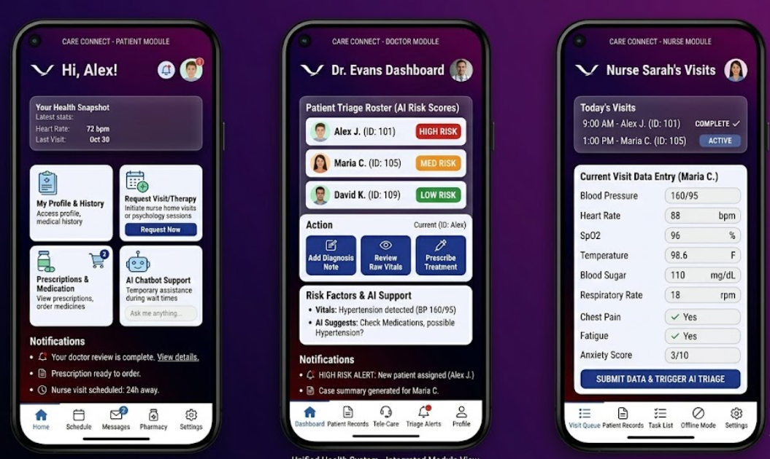

References
[1] L. Fernandez-Luque and T. Bau, "Health and Social Media: Perfect Storm of Information," Healthcare Informatics Research, vol. 21, no. 2, pp. 67–73, 2015.

[2] P. Mohan, V. Bairavi, and B. Visalakshi, "Application of Machine Learning Algorithms for Disease Prediction," International Journal of Engineering and Technology, vol. 3, no. 5, 2011.

[3] Z. Obermeyer and E. J. Emanuel, "Predicting the Future Big Data, Machine Learning, and Clinical Medicine," New England Journal of Medicine, vol. 375, pp. 1216–1219, Sep. 2016.

[4] E. J. Topol, "High-Performance Medicine: The Convergence of Human and Artificial Intelligence," Nature Medicine, vol. 25, pp. 44–56, 2019.

[5] E. Choi, M. T. Bahadori, J. Sun, J. Kulas, A. Schuetz, and W. Stewart, "RETAIN: An Interpretable Predictive Model for Healthcare using Reverse Time Attention Mechanism," in Advances in Neural Information Processing Systems, 2016.

[6] K. Kario et al., "Digital Hypertension 2020: From Evidence to Practice," Hypertension, vol. 76, no. 5, pp. 1334–1343, 2020.

[7] F. Lüscher et al., "Remote Patient Monitoring and Chronic Disease Management: A Systematic Review," Journal of Medical Internet Research, vol. 24, no. 3, e30439, 2022.

[8] Birdie Care Ltd., "Home Care Management Platform," [Online]. Available: https://birdie.care. [Accessed: 2026].

[9] Sehat Kahani Pvt. Ltd., "Sehat Kahani Telemedicine Platform," [Online]. Available: https://www.sehatkahani.com. [Accessed: 2026].

[10] Practo Technologies Pvt. Ltd., "Practo Telemedicine and Health Records," [Online]. Available: https://www.practo.com. [Accessed: 2026].

